Test Project Day 4
Part 2
  - Graphic Design Technology
FR

Introduction to Test Project

Contents
- WSC2019_TP40_Day4_Part2.docx (this file)
- Appendix 1.0 – IWD_Logo_four_versions.ai (AI file with four versions of logo)
supplied on competitor desktop in folder called: WSC2019_TP40_Day4_CompetitorFiles
- Appendix 1.1 (Folder) - Images
supplied on competitor desktop in folder called: WSC2019_TP40_Day4_CompetitorFiles
- Appendix 1.5 – Interactive Brochure Text
supplied on competitor desktop in folder called: WSC2019_TP40_Day4_CompetitorFiles

Introduction
International Women's Day (IWD) is celebrated on March 8 every year. It is a major event for women's rights.
IWD today ranges from being a public holiday in some countries to being largely ignored in other countries. In some places, it is a day of protest — in others, it is a day that celebrates womanhood.
Each year, IWD focuses on different important subjects related to women’s rights. In 2020, IWD will focus on empowering women through education and skills.
The main corporate colour for IWD is purple and they would like to retain their identity by having this colour as the dominant one. Additional colours may be used, but they should be warm and harmonious with the purple.

Description of project and tasks
Demographics:
- Gender: Male (50%) and Female (50%)
- Age: All
- Location: International
- Income: All
- Other: This message is for all people throughout the world
Task:
- Interactive brochure

Instructions to the Competitor
Create a folder on your desktop called YY_TESTPROJECT_DAY4 (where YY represents the number of your workstation). All final and working files must be included in this folder.
You must include your workstation number on the presentation board and printouts for marking and delivery to your workstation (the number should be included outside of the artwork).
This folder structure will be as follows:
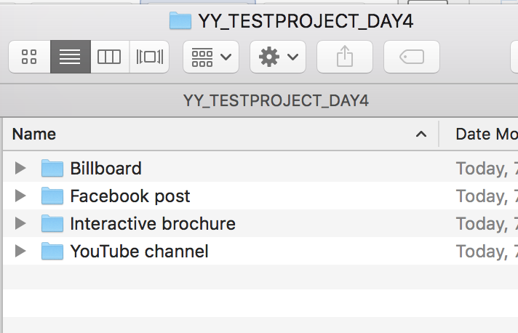

Task 4: Interactive Brochure
You will design an 8 page interactive digital brochure that will be available on the IWD’s website. The purpose of the brochure is to showcase women of the future.
Vous allez concevoir une brochure numérique interactive de 8 pages qui sera disponible sur le site Web de la IWD. Le but de cette brochure est de présenter les femmes du futur.
The requested interactive elements are indicated in <blue>.
Specifications
Colour and ICC Profile
- sRGB IEC61966-2.1
Size
- 8 x Single pages: 170mm wide x 170mm high
Resolution
- 150ppi
Page 1 to include:
- Logo
- Text in Appendix 1.5 - Brochure Text (as per the appendix instructions)
- Additional vector or raster graphics (if desired)
- <Website clickable link (hyperlink)> https://www.internationalwomensday.com/
- <Forward button icon that goes to the next page when clicked>
Master Pages Elements
Pages 2–7 must include:
- Page numbers and footer text in Appendix 1.5 - Brochure Text (as per the appendix instructions)
- Additional graphics (if desired)
- <Website clickable link (hyperlink) to be active on pages 3–7> https://www.internationalwomensday.com/
- <Forward button icon that goes to the next page when clicked>
- <Home button icon that goes to the first page when clicked>
Page 2 — Inner Front Cover to include:
- Text in Appendix 1.5 - Brochure Text (as per the appendix instructions)
Page 3 to include:
- Text in Appendix 1.5 - Brochure Text (as per the appendix instructions)
Image: Jacqueline_1.jpg (you may edit the image)
- Additional graphics (if desired)
- <Forward button icon that goes to the next page when clicked>
- <Back button icon that goes to the previous page when clicked>
- <Home button icon that goes to the first page when clicked>
Page 4 to include:
- Text in Appendix 1.5 - Brochure Text (as per the appendix instructions)
Image: Anna_1.jpg (you may edit the image)
- Additional graphics (if desired)
- <Forward button icon that goes to the next page when clicked>
- <Back button icon that goes to the previous page when clicked>
- <Home button icon that goes to the first page when clicked>
Page 5 to include:
- Text in Appendix 1.5 - Brochure Text (as per the appendix instructions)
Image: Caroline_1.jpg (you may edit the image)
- Additional graphics (if desired)
- <Forward button icon that goes to the next page when clicked>
- <Back button icon that goes to the previous page when clicked>
- <Home button icon that goes to the first page when clicked>
Page 6 to include:
- Text in Appendix 1.5 - Brochure Text (as per the appendix instructions)
Image: Amelia_1.jpg (you may edit the image)
- Additional graphics (if desired)
- <Forward button icon that goes to the next page when clicked>
- <Back button icon that goes to the previous page when clicked>
- <Home button icon that goes to the first page when clicked>
Page 7 to include:
- Text in Appendix 1.5 - Brochure Text (as per the appendix instructions)
Image: Pearl_1.jpg (you may edit the image)
- Additional graphics (if desired)
- <Forward button icon that goes to the next page when clicked>
- <Back button icon that goes to the previous page when clicked>
- <Home button icon that goes to the first page when clicked>
Pages 8 to include:
- Text in Appendix 1.5 - Brochure Text (as per the appendix instructions)
- Logo
- Additional graphics (if desired)
- <Back button icon that goes to the previous page when clicked>
- <Home button icon that goes to the first page when clicked>
File Types:
- Working File: InDesign
- Vector Image (links): AI, EPS,
- Raster Image (links): JPEG, PNG
- Final File: PDF/X-4:2008
Naming:
Note: YY represents your competitor number
Folder name: Brochure
- Brochure file name: YY_IWD_Brochure.indd
- Brochure file name: YY_IWD_Brochure.pdf
You must deliver
Printout
- Colour with each page centred on A4. Trimmed to 100% (actual size).
- Sortie couleur comprenant chaque page centrer sur A4. Couper a 100%
- 1 x colour A3 printout as per sample below
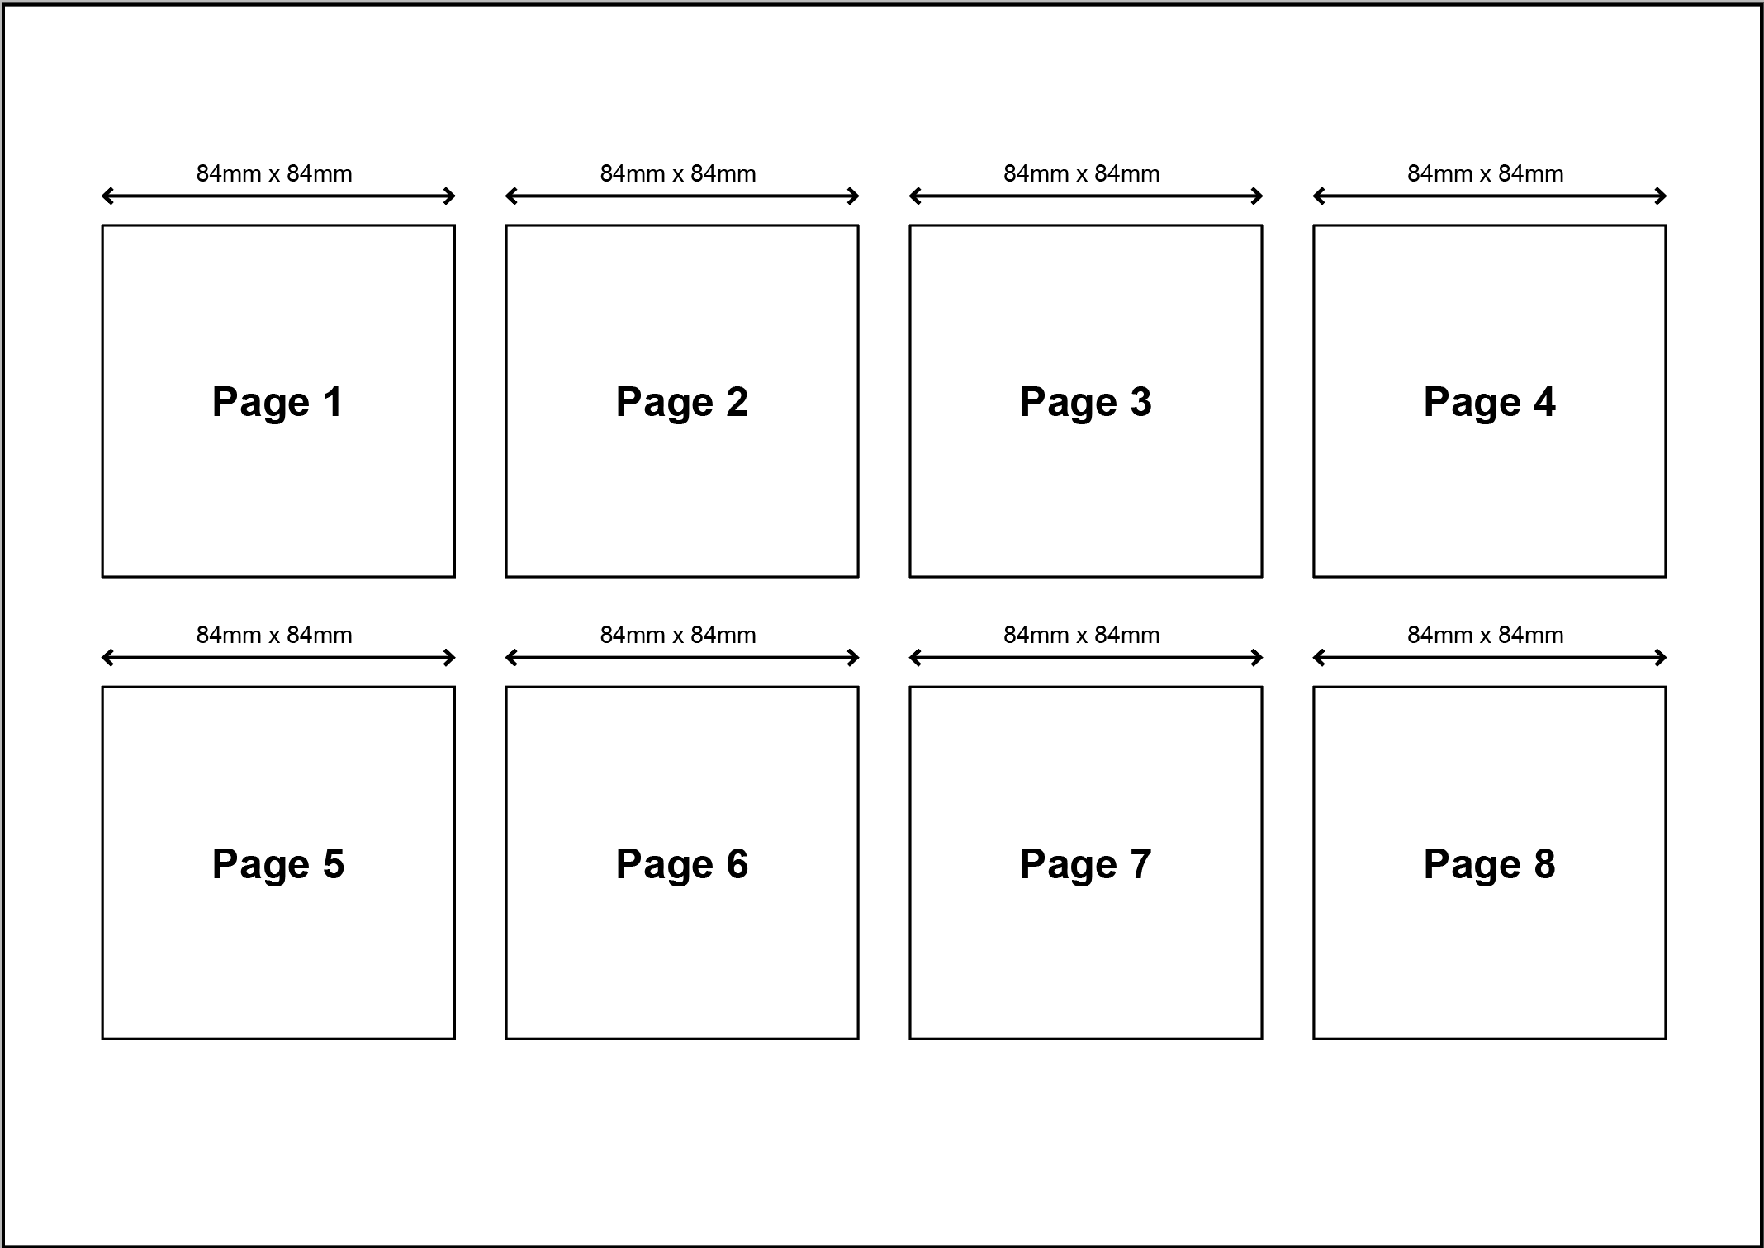

Files
- 1 x InDesign File
- 1 x PDF file
- You must include a packaged Adobe InDesign folder for submission that includes all links and fonts used.
- You must include any working files in a separate folder called: Working files

Marking Summary
The Marking Summary will be provided during the briefing session or to your workstation on C4.

Appendix 1.5 — Brochure Text
Note: Text to be included in brochure is Blue in colour
The black text is not to be included (they are instructions)
Page 1
Women of the Future
International Women’s Day
March 8
Raise awareness against bias
Take action for equality
Master Page
- page number
- footer:
Women of the Future
www.internationalwomensday.com
Page 2
International Women's Day is powered by the collective efforts of all
Collective action and shared ownership for driving gender parity is what makes International Women's Day successful. So make International Women's Day your day and do what you can to truly make a positive difference for women.
A balanced world is a better world.
Celebrate women's achievement.
Page 3
When young women are empowered to create opportunities for ourselves, we can design the future world we want to live in. That’s what I believe in, that’s the reason I am part of this movement.
Jacqueline Tanzer
Page 4
I am a global citizen who cares about world’s problems and who dares to look for solutions.
Anna Prokopenya
Page 5
I want girls and young women to feel empowered by the fact that they can do anything. Will you help me create a world where we allow them to dream just as big as I did, with only the sky as the limit?
Caroline Söderqvist
Page 6
I have learnt to communicate effectively to large groups, one on one and through social media, as well as develop confidence and team working skills. I have a message and a purpose which flows into all areas of my life.
Amelia Addis
Page 7
I believe we are the leaders of today. We are brave, fearless, and energetic, we are full of energy, hope, and imagination to create innovative ideas that can shape a better world.
Pearl So
Page 8
For more inspiring stories and all the latest updates, visit: www.internationalwomensday.com

